Dr.M.Abarna Muthulakshmi Email: drabarnaashok@gmail.com
Phone: 9841337003/9003357336
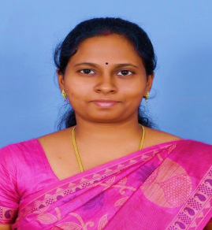
______________________________________________________________________________
An enthusiastic dermatologist with training & experience in various dermatosurgery & cosmetology procedures like lasers, botox & fillers.
Qualifications
M.B.B.S- Tirunelveli Medical College (2003 – 2009)
M.D -D.V.L(Dermatology,Venereology and Leprosy) - Government Medical College, Thiruvananthapuram (2010 -2014)
Experience: 13 Years
Resident( M.B.B.S) - Tirunelveli Medical College :March 2008 – March 2009
Junior Resident, Government Medical College, Thiruvananthapuram : July 2010- January 2014
Consultant dermatologist, AKJN skin and laser clinic, Chennai. : 6 months
Assistant Professor – Chettinad Hospital and Research Institute, : April 2015- April 2019
Associate Professor- Chettinad Hospital and Research Institute : 10th April 2019-19 June 2020
Consultant Dermatologist
- Dermaspace Skin Hair Nail & Cosmetology Clinic, Neelankarai, Chennai
- GEM Hospitals, Perungudi
- CURI Hospital, Thoraippakkam
- Arshan Multispeciality Hospital, Navalur, OMR
Member, Institutional Human Ethics Committee, Chettinad Academy of Research & Education – February 2018-June 2020
Has attended various conferences in the field of Dermatology, Venereology, Leprosy, Cosmetology and Biomedical & Health research.
Life Member in various associations:
- Indian Association of Dermatology Venereology & Leprosy (IADVL)
- Association for the Study of Sexually Transmitted Diseases and AIDS (IASSTD)
- Cosmetic Dermatology Society (India) {CDSI}
- Association of Cutaneous Surgeons of India (ACSI)
Personal Details:
Date of Birth : 13th December, 1985
Marital Status : Married
Address : No.76, Raja Nagar,
2nd Cross Street,
Neelankarai, Chennai- 600115
Clinic Address : Dermaspace Skin, Hair, Nail & Cosmetology Clinic
No.105A, Workers Estate, Ist Main Road,
Neelankarai, Chennai-600115

